# BAIT 507 Homework Assignment 2

**Purpose:**

Data analytics can provide important insights into the environmental and social practices of businesses. This assignment is an opportunity for you to apply the database knowledge to gain such insights. In reference to the United Nations’ sustainable development goals, this assignment aims to deepen your understanding of the relationship between database management and Goals 12 (Responsible Consumption and Production) and 13 (Climate Action).

**Database:**

The database has records about Consumer Carbon Incentives (CCI) programs. A CCI program provides individualized rewards for low-carbon consumer choices. An example is the Mobility for Green City program launched by a navigation and traffic application (app) called AMap. When consumers use the app to choose low-carbon transportation modes such as renting a shared bicycle, they earn carbon credits and then can use the credits to claim rewards in the AMap app.

The database has real-world data about CCI programs and fictitious consumer data. The entity-relationship diagram of the database is provided on the last page of this document. The database setup instructions are provided in the Homework 2 link in Canvas.

**What to do:**

* Answer the three data ethics questions based on query output. You can either use the output of any of the four queries or queries defined by yourself. Your answer for each question should not exceed 100 words. In addition, please show the query output in support of your answer.
* Answer the four queries using the CCI database. SQL statements are sufficient as your answers to the query questions.

**Who to work with:** You can choose to work alone or in a group of up to four members (including you). The group members can be different from those for homework 1. All group members must come from the same section.

**Where to ask questions:** Please use Piazza for Q&A. This way, everyone receives the same information. Piazza can be accessed via the Piazza link in Canvas, or directly at https://piazza.com/ubc.ca/winterterm12024/bait507ba1ba2

**How to submit:** Two submissions are required. First, please prepare your answers for the data ethics questions in a Word document, and submit the document to the Homework 2 (Data Ethics) link in Canvas. This part is due by **noon Nov 27**. Second, please prepare your answers for the queries in a Word document and submit the document to the Homework 2 (Queries) link in Canvas. This part is due by **11:59PM on Nov 29.** If you work in a group, only one of the group members should do the submissions. Please include every group member’s name in the group answers.

**Data Ethics Questions**

1. Do you see a risk for the CCI rewards to bias against customers with a specific profile (for example, in a certain age group, with a particular economic status, or in a particular geographic region)?
2. Do you see a potential for the CCI rewards to unintendedly increase carbon emission?
3. Choose one of the ethics issues above and recommend changes in the CCI program that help to remedy it. You don’t need to support your argument with any query output.

# Queries

1. Show activity ID, activity name, and the number of users that have participated in each activity. Those activities that have never been participated should be included in your output. Sort the output by the number of users in descending order. Sample output below.

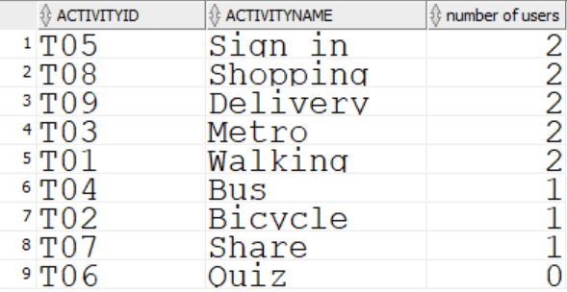

1. Show the ID and name of the CCI users, the total number of distinct activities participated by the users, the ID and name of the users’ referrers, and the total number of distinct activities participated by the referrers. Sample output.

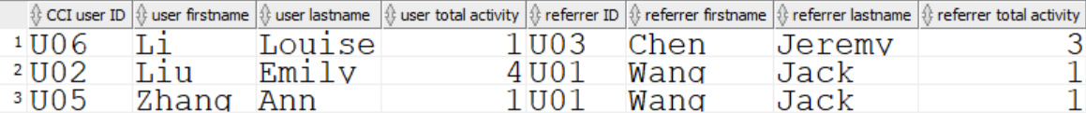

1. Find the current credit amount of each user (calculated as the total credit earned - the total credit claimed). Total credit earned from each participation in an activity is CreditEarned*ParticipationAmount. Total credit claimed from each reward claim is ClaimedRewardAmount*RequiredCreditAmount. Show user ID, user name, and current credit amount. Sort the output by the current credit amount in ascending order. Sample output.

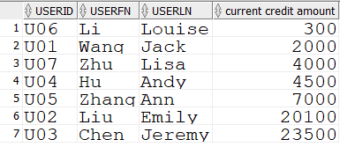

1. Find the ID and name of the top 3 most participated activates by total credit earned. Total credit earned from each participation in an activity is CreditEarned*ParticipationAmount. Add a column named “rank” in the output to show “first” next to the most participated activity name, “second” next to the second most participated, and “third” to the third most participated. Sample output.

